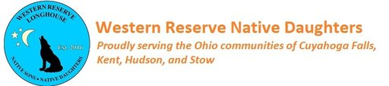

**12th Annual**

**Native Daughters Golf Outing Fundraiser**

*Sponsored by*

 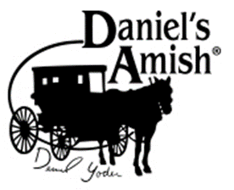

**When:** Monday, July 26, 2021

# **Where:** Ellsworth Meadows Golf Club

# 1101 Barlow Rd.

# Hudson, Ohio 44236

**Time:** 7:30AM - Registration

9:00AM – Shotgun Start

**Format:** Four Man Scramble

$425/Foursome ($75 savings)

$125/Golfer

**All golfers receive the following:**

18 holes of golf with cart

Breakfast/Lunch/Dinner (Catered TBD)

Adult Beverages Included

Optional contests during play

Various Prizes

**Sponsorships needed:**

Event Sponsors $1,250, Longest Drive $250, Closest to Pin $250, Hole Sponsors $150

Hole-in-one $150 & (Insurance Premium Approximately $250), Raffle Prizes

**To register or sponsor visit or call**

[**https://www.wrnsd.org/daughters-golf-outing.html**](https://www.wrnsd.org/daughters-golf-outing.html)

**Dean Paolucci 330-906-2375 dean@paoluccilawfirm.com**

***(Western Reserve Longhouse is a 501c3 Non-Profit Organization)***

